
Tampa Funcoast ASC Minutes
February 8, 2025
First Church of God, 2202 E. Busch Blvd., Tampa, FL 33612

Chair: Dan N. Vice Chair: Open
Secretary: Morgan B. Alt. Secretary: Open
Treasurer: Danielle C. Alt Treasurer: Open
RCM #1: Richard RCM #2: Myra
Policy: Julie S.
ASC opened @ 2pm by Dan N.
READINGS
Service Prayer: All
Purpose and Function (Page 6 of Policy): Dan N.
Service Motives: (pg 4 of policy): Tyler
12 Traditions: Liz C.
12 Concepts: David H.
WELCOME NEW ATTENDEES:
- David H.
- Erin
- Sierra
- Corey
- T

NEW GROUPS:
- Brandon Men’s Group

SECRETARY REPORT:
If I missed anything in this month’s minutes or need to make corrections, please let me know. Located on the back table are several important forms:
- The Contact Sheet is for ‘updates only’ so we have an accurate Contact list to be able to email the groups and other trusted servants the minutes or any other pertinent information. Please print clearly.
- Please use Sign-in sheet to sign in.
- Use Meeting Change Forms so we can accurately update the meeting schedule. Accurate meeting information is important, so we have the correct information on the website and meeting schedules.
- Motions Forms – New motions must be turned in by New Business to be heard today.
- GSR Orientation is at 1:30pm before ASC.
- There are 28 groups eligible to vote so quorum will be 14.
- Ineligible Groups:
  - Go with the Flow
Please email all reports to funcoastsecretary@tampa-na.org by Saturday March 15th, so we can have ample time to review the minutes for accuracy before they are distributed.

Thank you for allowing me to serve. Morgan B.

Open Forum:
- GSRs with Home-Group issues:
  - David H. - TUG – New Meeting Wed. from 8:30-9:30. This will be a literature meeting

- Any member wishing to address the ASC:
  - Joel – There is still leftover merchandise from FACNA
  - Dan – All flyers must be approved by Policy before making it to the floor.

ROLL CALL: Groups, ASC Officers, Subcommittee Chairs – See Addendum A

ABSENT/RESIGNATION LETTERS: None

VICE CHAIR REPORT:

East Co East Coast Convention will be coming to speak with us during an ASC in open forum date TBD. We have 2 regional motions coming to the ASC floor to be sent back to the homegroups.

LDO REPORT:
Good afternoon,
Thank you for letting me be of service. I will be working with the new LDO for at least one month to help in the transition of this position, should that person be elected today. If that does not happen I will continue to serve as your LDO. We have several volunteers that help put your literature orders together to. Please give them your thanks.
A volunteer has also picked up the literature for this area this past month. That same individual also picked up the literature for H&I and delivered it to the H&I literature person. In lieu of that this has saved our area money on shipping. I’d like to see this area create or come up with a regular system to better serve this area. This savings that has happened the last 10 months or so also needs to be transparently recognized on the floor or somewhere so that all members who would like to know about it can see it. There is a dollar amount for this.

Thank you, Alexander L.

RCM REPORT:
● FRSC met January 17-19, 2025 in Orlando. Tampa Funcoast RCMs were in attendance.
● The next FRSC will be March 14-16, 2025 in Orlando. All members are welcome to
attend in person or virtually. Go to www.naflorida.org for the virtual link.
Area Support (Saturday):
Topics:
● Insurance for Areas and Groups.
● Increasing Participation in Service
● Respect and Conduct During Area Meetings
● Handling Personal Grievances at the Area Level
● Sustaining Service When Trusted Servant Positions Are Vacant
● H&I Participation by Members Under 18
● Hybrid Attendance for Elected Positions

Fellowship Development (Saturday)
● RCM Term Lengths- A major discussion point revolved around the length of RCM terms
and whether changes should be made to the current structure. Proposals for Extended
Terms:
○ 2-Year RCM-2 + 2-Year RCM-1 (4-Year Total)
■ Suggested as an ideal model for continuity.
■ Allows for better training and mentorship of RCMs.
○ RCM-3 Model (Three RCMs Rotating)
■ Some areas have adopted a three-tier system for better knowledge
retention.
Opposition to Longer Terms:
○ Some members cited the importance of spirit of rotation.
○ Concerns about difficulty in finding members willing to commit for multiple years.
● Low participation in the HRP volunteer pool.
● Motions 1 and 12 of the CAR Report were discussed. Overall consensus was not met
across the Florida Region.
● An amendment to motion 1 was discussed.

FRSC Business (Sunday):

Nominations and Elections:
Position: Technology Alternate Resource Coordinator
Member: Anthony L - Tampa Funcoast
Outcome: Elected

Old Business:
(None)
New Business:
Proposal Number: 2025-01-01
Maker: Admin Body
Proposal: To pass the 2025-2026 Budget
Intent: To have a working budget
Financial Impact: $121,653.00 in budgeted expenses. See Budget.
Outcome: Sent to Areas
Proposal: 2025-01-002
Maker: Forest Area
Proposal: CAR Motion 1
To adopt for the 2025 Interim WSC and the 2026 WSC only:
If a motion has consensus in an initial straw poll that’s 80% or more in either support or
non-support, the co-facilitators will announce the results as a final decision.
Amendment:
To add to motion 1 that 20% (for or against) can submit their position with comments for
inclusion in the minutes in order to not take away the voices of those members (or the
voice of the minority).
Intent: To be more in line with Concept 9; even if the minority voice only changes the decision
once then it is better
than eliminating that voice.
Spiritual Impact: WSC
Financial Impact: 0
Guide to Florida Regional Service Change: none
Outcome: Passed

Proposal: 2025-01-003 – Vote at March ASC
Maker: First Coast Area & HRP
Proposal: To eliminate the Florida Service Symposium as an FRSC hosted event. For
theFlorida Regional Service Committee to no longer host the Florida Service Symposium
and to remove all references in the Guide to Florida Regional Service.

Intent:
To let go of the FSS with the hopes that this would allow the Southeast Zonal Forum or another
Region/Zone to assume the hosting responsibilities for this event as this will free up a large
portion of our funds.
Rationale:
The Florida Regional Service Committee inaugurated the Florida Service Symposium in 2005
and has hosted this event every other year since. Except for 2021 all were held in person. The
event has always been provided to members at no cost. We have interacted directly with the
medical field, treatment industry, the Department of Corrections, Law Enforcement, the legal
system, and government officials to name a few. The Florida Service Symposium was the first
event of its kind, attracted NA members from around the world, brought
trusted servants of our fellowship together from coffee makers to World Board members. For 20
years the Florida Service Symposium has continued to fulfill its goal of becoming a primary
model for trusted service training and all levels of service by providing cutting edge training not
typically found elsewhere in our fellowship; communicating NA World Service strategic plans,
initiatives, and current projects. We have fulfilled our mission and become a model for similar
events now active throughout the world. Because there are now several similar events
presented by adjacent zones, the Florida Service Symposium is no longer a priority event for
the World Board and NA World Service staff. The Florida Service Symposium has become
expensive to host and the pandemic has made in-person events less well attended by
professionals and members alike. Hotels, meeting space, food & beverage
costs, travel costs, and declining donations have made this event cost prohibitive.
Financial Impact:
The FRSC would have up to $31,200 to not only assist in other similar events but have more
funding available for assistance to areas and perhaps additional donations to support NA World
Services.
Spiritual Impact:
Letting go of the Florida Service Symposium would have a positive spiritual impact by allowing
us to recognize our place in the fellowship as a whole and would allow others to benefit, grow,
and have the first-hand experience that Higher Power has allowed us to have for the last 20
years.
Outcome: Sent to Areas

Treasurer's Report:
Hello everyone,
On November 1, 2024, the opening bank balance was $32,694.42. After deposits of $13,716.67
and expenses of $10,785.60 on December 31, 2024, the ending book balance was $35,625.49.
After deducting $10,000.00 withheld for the next RSC, the Prudent Reserve of $11,000.00, the
GSR Assembly Reserve of $8,000.00, and the Florida Service Symposium Reserve of
$7,000.00 the available balance was $-4,574.51. We will not be making a donation to NAWS.

As of RSC held on January 19, 2025, we received $4,330.09 in income and had $5,962.39 in
expenses. Additionally, we allocated the monthly reserve of $400.00 for the GSR Assembly &
$800.00 the Florida Service Symposium. Therefore, after RSC business the available
balance was $-7,406.81. The following pdfs will include the treasurer's report with banking
summary, income & expense summary, contribution summary, profit and loss, balance sheet,
budget vs actual report and bank statements.
ILS,
Danette R. – Treasurer
Lyla – Alternate Treasurer

Additional Information:
● There are several H&I and Corrections initiatives happening, such as FDC Volunteer and
the “Bridging the Gap” program. If you would like to be of service, please see one of us
after the meeting.

Are there any questions?
Thank you for allowing us to serve and thank you all for your service.

ASC SUB-COMMITTEE REPORTS:

ACTIVITIES: No Report Submitted

FRCNA SUPPORT: No Report Submitted

HELPLINE: No Report Submitted

HOSPITALS & INSTITUTIONS:
Good morning fun Coast H&I business meeting this month had four new attendees and two returning attendees becoming members,

We voted on a motion to allow our members inside of institutions by themselves if the institution has staff on hand, the motion was denied.

H&I members thank you for allowing them to be of service as the front line against the Battle of addiction.
ITR COMMITTEE:
ITR Committee met virtually on 2/3 with 3 in attendance.
We discussed
- Updating the square storefront that was used by FACNA to allow GSR's to submit payments for ASC online
  - Working with the treasure to complete this
- Updating our web server primary contact information from an old contact to the FuncoastITR@tampa-na.org to be primary contact. This will ensure the IT committee can access and maintain the web server effectively.
- The IT committee wants to research to see if there is a discounted price with the web server (Host Gator) being that we are now a 5013c
- We had some issues with the printable PDF meeting schedules this month due to back end plug ends not working correctly on the Tampa-NA.org site. Our committee is actively working with Region to fix this.
  - As a result the printed meeting schedules this month are January PDF's. Please ensure that Free to Me ( Saturday 7 pm) is crossed off on any meeting schedules.
  - All flyers, meeting changes and information that needs to be loaded to website please send to funcoastitr@tampa-na.org
In loving service, Shannon C

POLICY: - Open with the Serenity Prayer
- Open Floor for Policy Related Issues:
- Old Business:
Motion: 2024-19 Date: 12/14/24
Maker: Women’s Hope Second: Second Chance

Motion: To direct the FL Region to dissolve the Service Symposium.

Intent: Same information given at the symposium is offered at the Regional Fellowship
Development, including being virtual. Also offered in the Guide to World Service and Guide to
Local Service literature. This symposium affects Region, Areas, and Groups financially.
Tradition 4: Each group should be autonomous except in matters affecting other groups or NA as
a whole.

Concept 11: NA funds are to be used to further our primary purpose, and must be managed
Responsibly. Financial accountability
Motion referred to Policy
- The Policy Committee suggested that this motion be ruled O/O/O. The RCMs are bringing a proposal to the ASC today stated the same intent. The proposal will be sent to the groups for voting.
New Business:
Motion: 2025-1P Date: 2/8/25
Maker: Treasurer: Second: Hope in Lutz
Motion: to add to H&I Page 20 – item # 9
All H&I Literature must be ordered through ASC LDO.
Intent: Single point of accountability – streamline
Findings:
- The motion is clear and concise.
- Information will be added to Policy on page 20 under Hospitals and Institutions, Responsibilities - #9
- It adheres to the 12, 12, & 12
- Financial impact: Concepts # 5&11
Concept # 5- For each responsibility assigned to the service structure, a single point of decision and accountability should be clearly defined.

Concept #11 -NA funds are to be used to further our primary purpose and must be managed responsibly.
Discussed the election schedule for the convention. The next Convention will be in 2029 as Policy was waived to move it to this time. After the Convention it will return to every 2 then 3 years so we always have our Convention on the multiples of 5 year anniversary. As Policy will be printed in 2027, the original Convention schedule will be reflected in the Policy.

Next meeting on 3/8/25
Note:
  - *Is the motion clear and concise?
  - *How and where will it be adopted into Policy?
  - * Does the Motion adhere to the 12, 12, & 12?
  - * Financial Impact –

PUBLIC RELATIONS: No Report Submitted

ANNOUNCEMENTS:
- Liz- Women’s Spiritual Retreat Movie Night 2/22 6pm-10pm 9191 W. Kirby Rd $10 admission $5 for kids 12 and under. Concessions and a fire pit. BRING YOUR OWN CHAIR OR BLANKET
- Joel- FACNA merchandise left if you are interested see Joel.

GSR ORIENTATION : None

TREASURER REPORT - See #Addendum B

OLD BUSINESS:
.
*Motion: 2024-18P Admin Budget
FOR:18 AGAINST:0 ABSTAIN:0 (PASSED)
*Motion: 2024-19 To direct The Florida Region to dissolve The Service Symposium
O/O/O
- Proposal at Regional level has same intent.
- Proposal will be going back to groups to bring a March vote
* Motion: 2024-20P H&I Budget
FOR:18 AGAINST:0 ABSTAIN:0 (PASSED)
* Motion: 2024-21P ITRC Budget
FOR:18 AGAINST:0 ABSTAIN:0 (PASSED)
Elections:
Activities – Freddie B.
FOR:18 AGAINST:0 ABSTAIN:0 (PASSED)
LDO – Jared C.
FOR:17 AGAINST:1 ABSTAIN:0 (PASSED)

New Business:

Took a straw poll for Sierra Nevada donation to be taken off hold in the bank account for use by the area. FOR:15

Motion 2025 1P???

Nominations:
HELPLINE CHAIR: STEVE M.
Steve M.13 years clean. Multiple years on helpline 2 or 3 different stints. Member of H&I for a couple of years. Will work hand in hand with multiple previous chairs. Jill D, Salena M, Donald D. Have served every position in my home group-currently supply person. Sit on board of the meeting place. - Bring Vote to March ASC
PUBLIC RELATIONS CHAIR: SAI C.
I wanted to follow up with my qualifications to be considered for the PR position.
I have currently have a little over a year clean. My current clean date is February 3rd 2024.
I am currently working steps with a sponsor whom has a sponsor.
I am part of the men's spiritual retreat committee.
I am the current GSR for my home group.
In the past, for different homegroups, I served a little over a year as a GSR and 1 year as a secretary.
I did two and a half years on a couple different panels in H&I. I also served a year and a half as the secretary on the H&I subcommittee.
I have the willingness to serve and to be of service.

Thanks ,Sai C.
Bring Vote to March ASC

OPEN POSITIONS:
Vice Chair Open
Alt. Secretary Open
Alt. Treasurer Open
BOD Member II Open
BOD Member III Open

Roll Call - Addendum – A
Attendance – 1st and 2nd Roll Call
Must be present for both Roll Calls to be considered present.
Y - Present; N – Absent; OPEN - Position needs to be filled; EX-Excused; UE-Unexcused;
Bold – Non-Voting Group

 | GROUP | 8.10.24 | 9.12.24 | 10.24 | 11.9.25 | 12.14.25 | 1.11.25. | 2.8.25
 | Aging In Recovery | Y/Y | Y/Y | Hurricane | Y/Y | Y/Y | Y/Y | Y/N
 | Brandon at Noon Group | Y/Y | Y/Y | Hurricane | Y/Y | Y/Y | Y/Y | Y/Y
 | Free to be Me | Y/Y | Y/Y | Hurricane | Y/Y | Y/Y | Y/Y | Y/Y
 | Freedom from Pain | N/N | N/N | Hurricane | N/N | Y/Y | Y/Y | Y/Y
INE | Go With the Flow | --- | --- | Hurricane | --- | Y/Y | N/N | N/N
 | Grow or Go | N/N | Y/Y | Hurricane | Y/Y | Y/Y | Y/Y | Y/Y
 | Heights of NA, The | Y/Y | Y/Y | Hurricane | Y/Y | Y/Y | Y/Y | Y/Y
 | High Lie | Y/Y | Y/Y | Hurricane | Y/Y | Y/Y | Y/Y | N/N
 | Hope In Lutz | Y/Y | Y/Y | Hurricane | Y/Y | Y/Y | Y/Y | Y/Y
 | Hyde Park NA | Y/Y | Y/Y | Hurricane | Y/Y | Y/Y | Y/Y | Y/Y
 | Ladies Lit | Y/Y | Y/Y | Hurricane | Y/Y | Y/Y | Y/Y | Y/Y
 | Life On Life's Terms | Y/Y | Y/Y | Hurricane | Y/Y | Y/Y | Y/Y | Y/Y
 | More Hope 1&2 | Y/Y | N/N | Hurricane | Y/Y | Y/Y | Y/Y | Y/Y
 | More Will Be Revealed | Y/Y | Y/Y | Hurricane | Y/Y | Y/Y | Y/Y | N/N
 | New Bite of Serenity | N/N | Y/Y | Hurricane | Y/Y | Y/Y | Y/Y | N/N
 | New Tampa NA | --- | --- | Hurricane | --- | Y/Y | Y/Y | N/N
 | New Way, A | Y/Y | Y/Y | Hurricane | Y/Y | Y/Y | Y/Y | Y/Y
 | Recovery in the Hood | Y/Y | Y/Y | Hurricane | Y/Y | Y/Y | Y/Y | Y/Y
 | Second Chance | Y/Y | Y/Y | Hurricane | Y/Y | Y/Y | Y/Y | Y/Y
 | Squeaky Clean | Y/Y | Y/Y | Hurricane | Y/Y | Y/Y | Y/Y | Y/Y
 | Stick N’ Stay | Y/Y | Y/Y | Hurricane | Y/Y | Y/Y | Y/Y | Y/Y
 | Sunset Solutions | Y/Y | Y/Y | Hurricane | Y/Y | Y/Y | Y/Y | Y/Y
 | Tampa Unity Group (TUG) | Y/Y | Y/Y | Hurricane | Y/Y | Y/Y | N/N | Y/Y
 | Time is Now, The | --- | Y/Y | Hurricane | Y/Y | Y/Y | Y/Y | N/N
 | Together We Can | Y/Y | Y/Y | Hurricane | Y/Y | Y/Y | Y/Y | Y/Y
 | War is Over, The | --- | --- | Hurricane | Y/Y | Y/Y | Y/Y | Y/N
 | Women's Hope | Y/Y | Y/Y | Hurricane | Y/Y | Y/Y | Y/Y | Y/Y
 | Workshop. The | Y/Y | Y/Y | Hurricane | N/N | Y/Y | Y/Y | Y/Y

 | ADMIN/ Subcommittee Chairs | 8.10.24 | 9.12.24 | 10.24.24 | 11.9.24 | 12.14.24 | 1.11.25 | 2.8.25
 | Chair | Y/Y | Y/Y | Hurricane | Y/Y | Y/Y | Y/Y | Y/Y
 | Vice Chair | Y/Y | Y/Y | Hurricane | Y/Y | N/N-EXC | OPEN | OPEN
 | Secretary | Y/Y | Y/Y | Hurricane | Y/Y | Y/Y | Y/Y | Y/Y
 | Alt. Secretary | OPEN | OPEN | Hurricane | OPEN | OPEN | OPEN | OPEN
 | Treasurer | Y/Y | Y/Y | Hurricane | Y/Y | Y/Y | Y/Y | Y/Y
 | Alt. Treasurer | OPEN | OPEN | Hurricane | OPEN | OPEN | OPEN | OPEN
 | RCM #1 | Y/Y | Y/Y | Hurricane | Y/Y | Y/Y | Y/Y | Y/Y
 | RCM #2 | OPEN | CLOSED | Hurricane | Y/Y | Y/Y | Y/Y | Y/Y
 | Policy | CLOSED | Y/Y | Hurricane | Y/Y | Y/Y | Y/Y | Y/Y
 | Activities | OPEN | OPEN | Hurricane | OPEN | OPEN | OPEN | CLOSED
 | Convention | N/N | N/N | Hurricane | --- | --- | --- | ---
 | FRCNA Support | OPEN | OPEN | Hurricane | OPEN | OPEN | OPEN | Y/Y
 | Helpline | OPEN | OPEN | Hurricane | OPEN | OPEN | OPEN | OPEN
 | H&I | Y/Y | Y/Y | Hurricane | Y/Y | Y/Y | Y/Y | Y/Y
 | ITR Coordinator | Y/Y | Y/Y | Hurricane | Y/Y | Y/Y | Y/Y | Y/Y
 | LDO | Y/Y | Y/Y | Hurricane | Y/Y | Y/Y | OPEN | CLOSED
 | Alt. LDO |  |  | Hurricane | Y/Y | Y/Y | OPEN | OPEN
 | Public Relations | OPEN | OPEN | Hurricane | OPEN | OPEN | OPEN | OPEN

Treasurer’s Report - Addendum # B

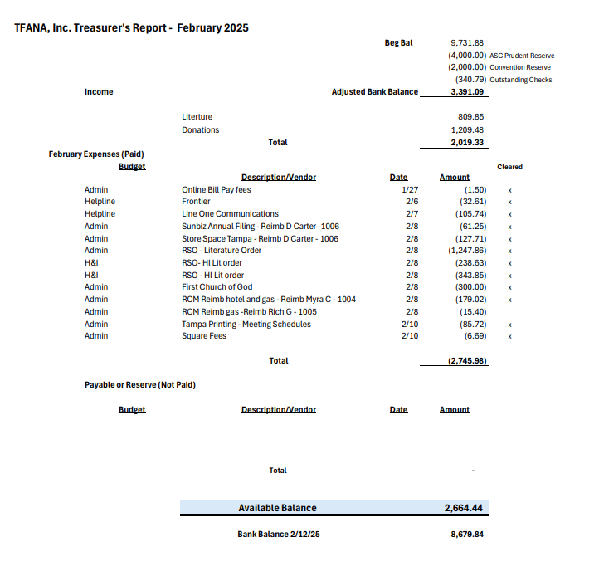
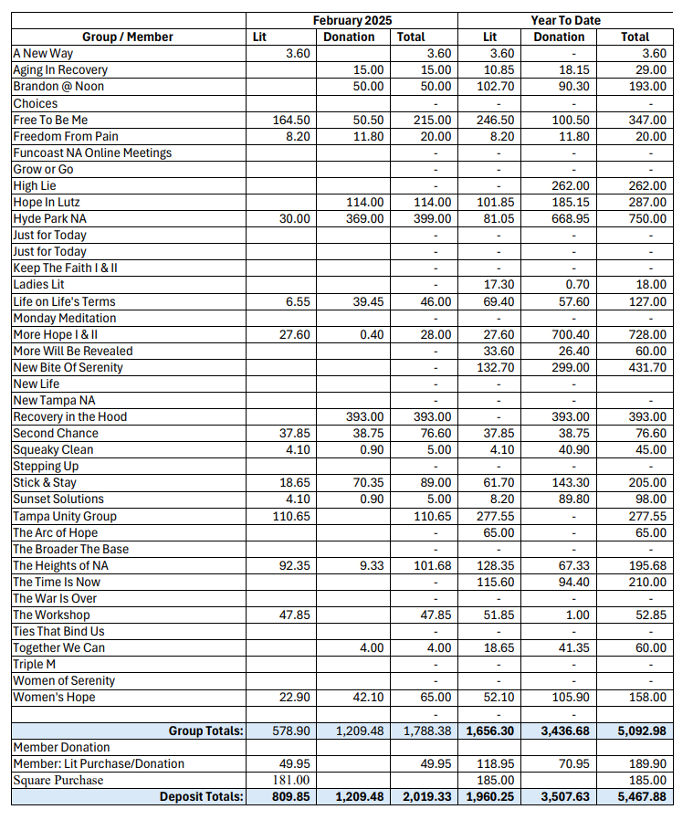

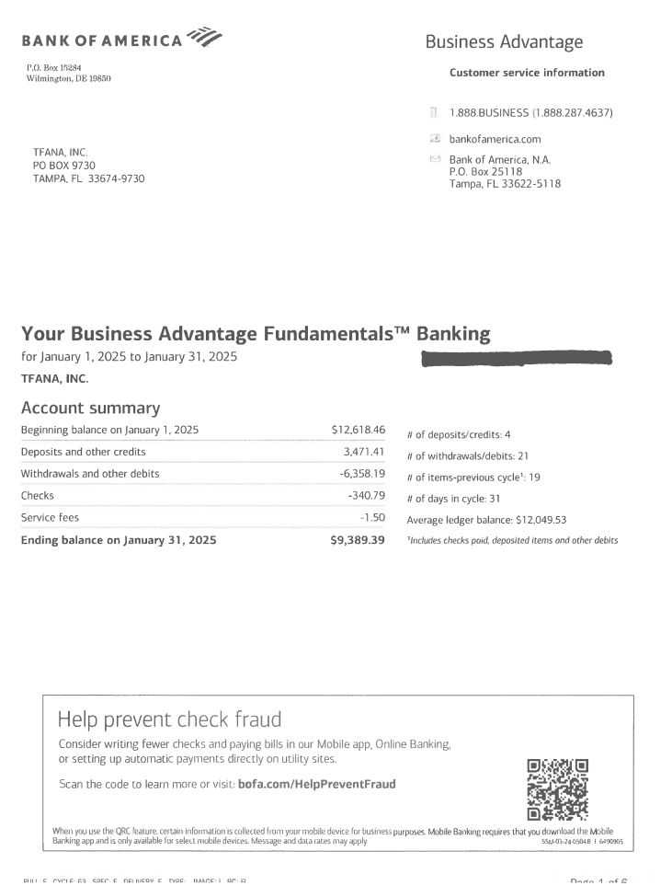
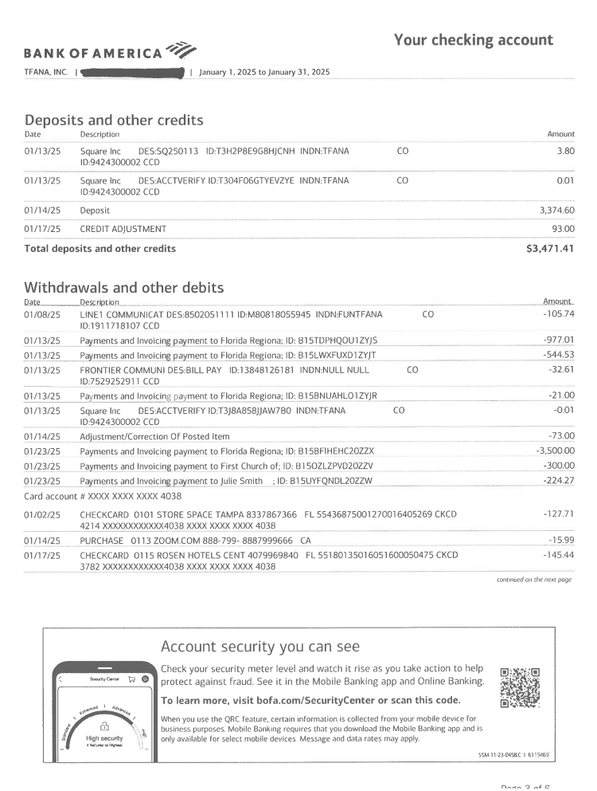
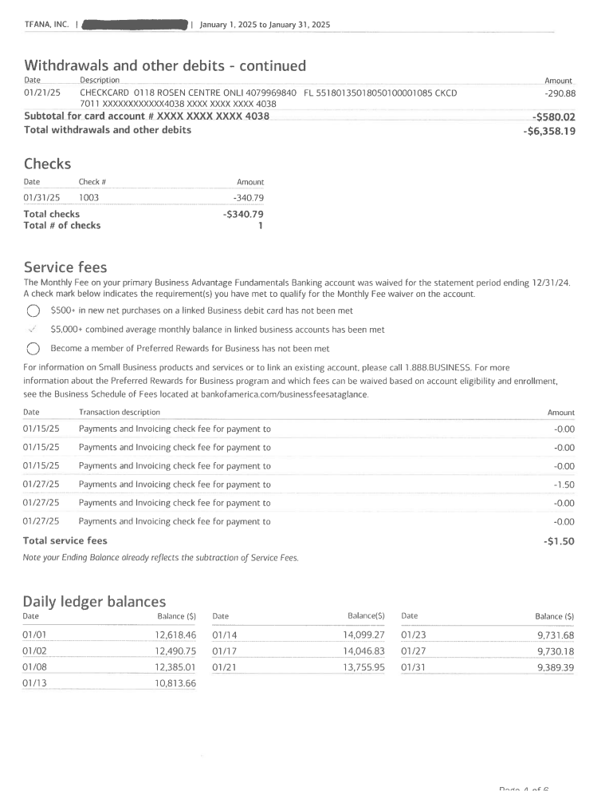

Regional Budget – Addendum # C
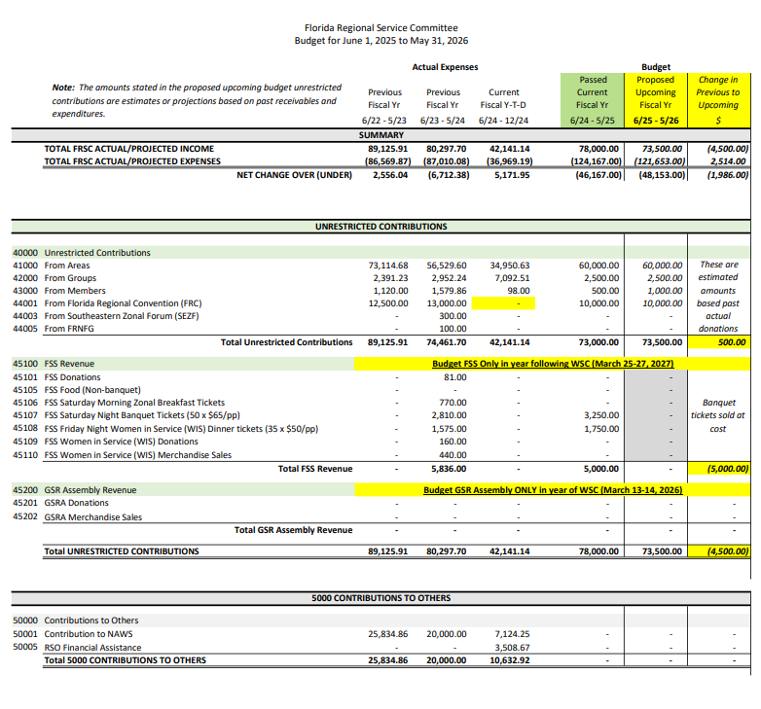

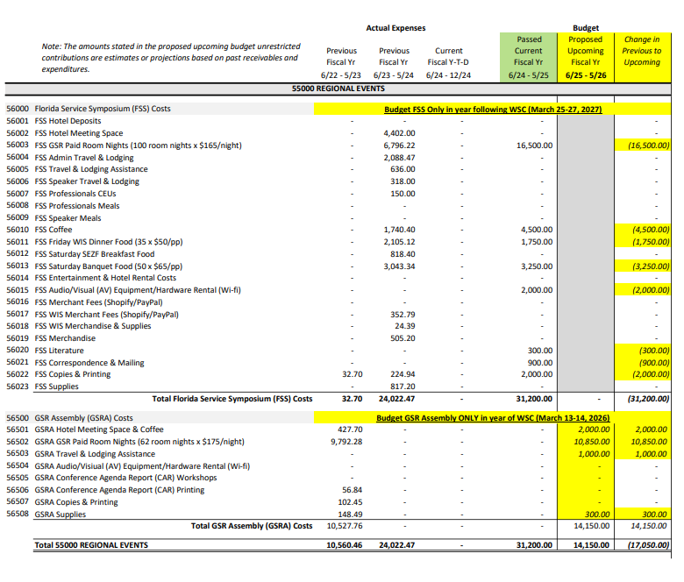

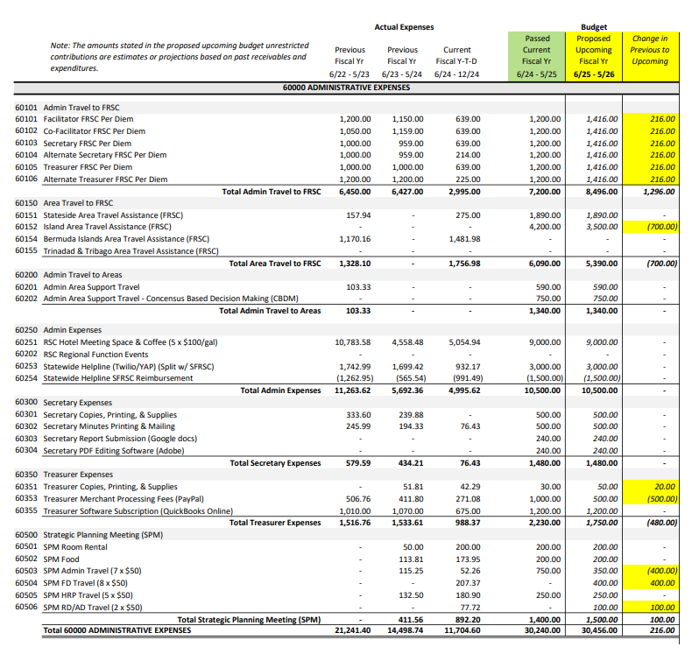

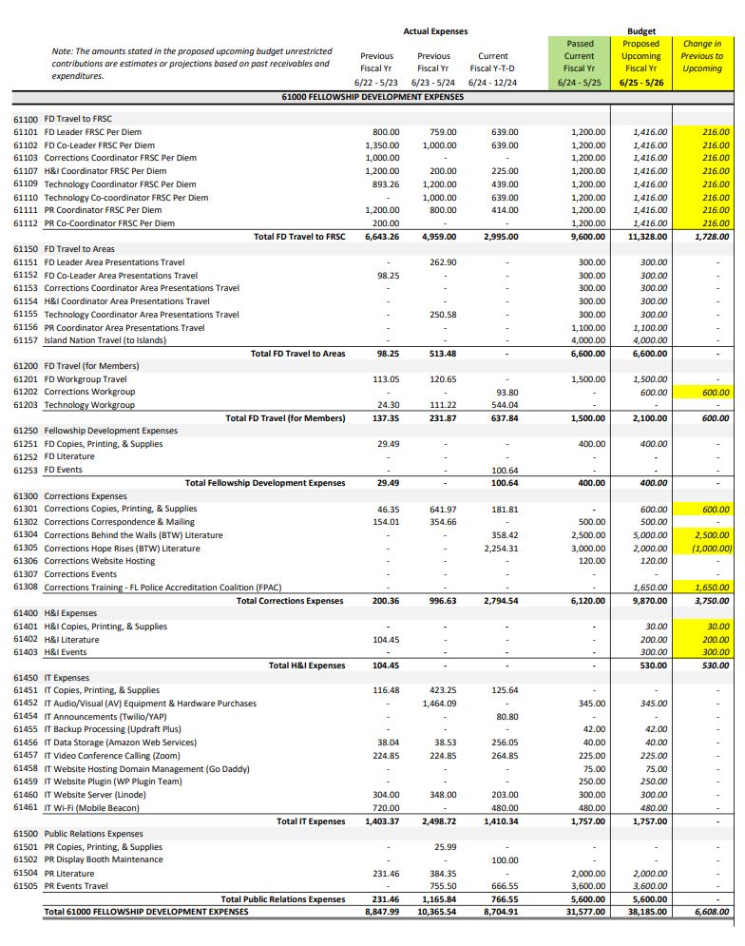
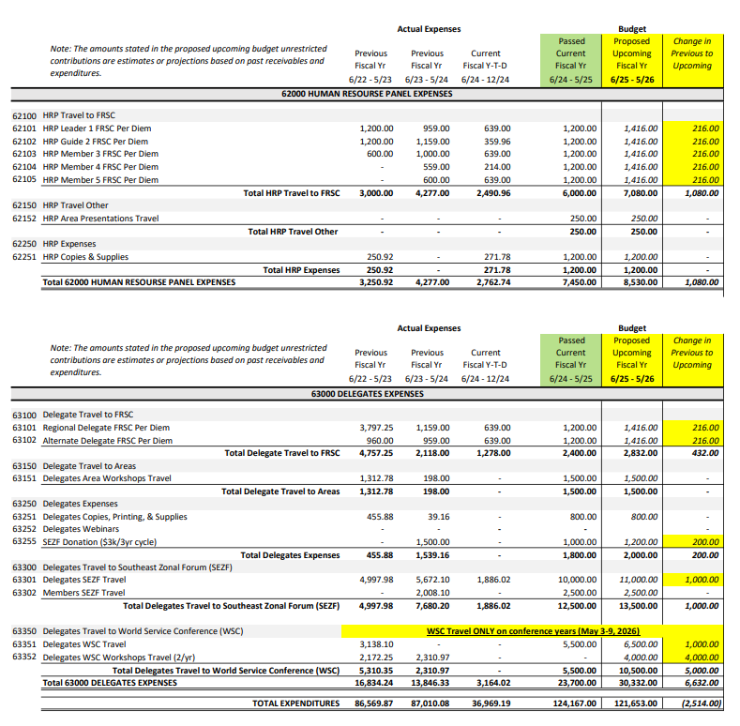
Vote in March

